Setting up CentOS and Ubuntu Servers

After accepting the post of Systems Administrator for Acme, I have decided I will use CentOS and Ubuntu Linux distributions for setting up the server.

CentOS

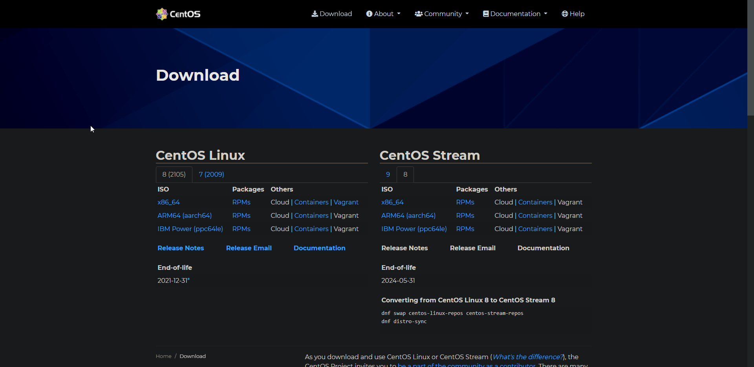

Firstly, we’ll be setting up a CentOS server using only the Command Line Interface. To download the ISO for the operating system we will go to the official CentOS download page and click on the “x86_64” link under 8 (2105). This will download the CentOS 8 ISO I need to create a server.

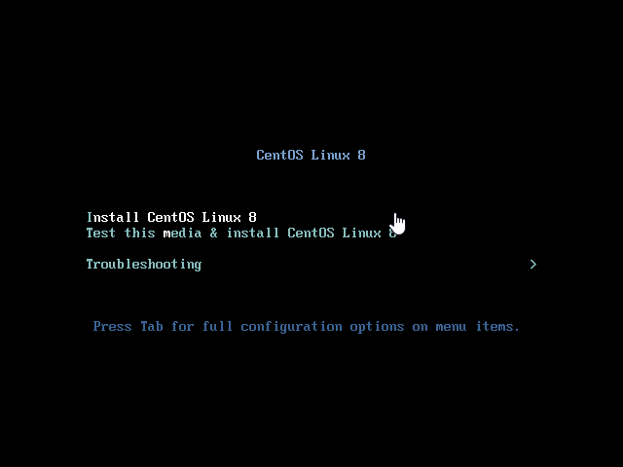After downloading and mounting the ISO, you will see this screen. Use the arrow keys to highlight “Install CentOS Linux 8”, then press enter. This will begin the installation progress.

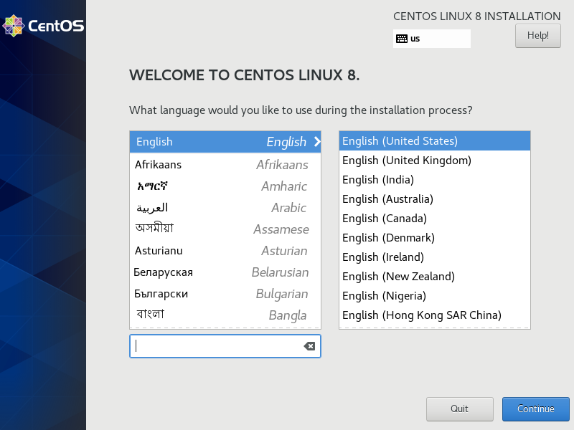Soon you will be met with this installation screen. Select your preferred language and country and click continue

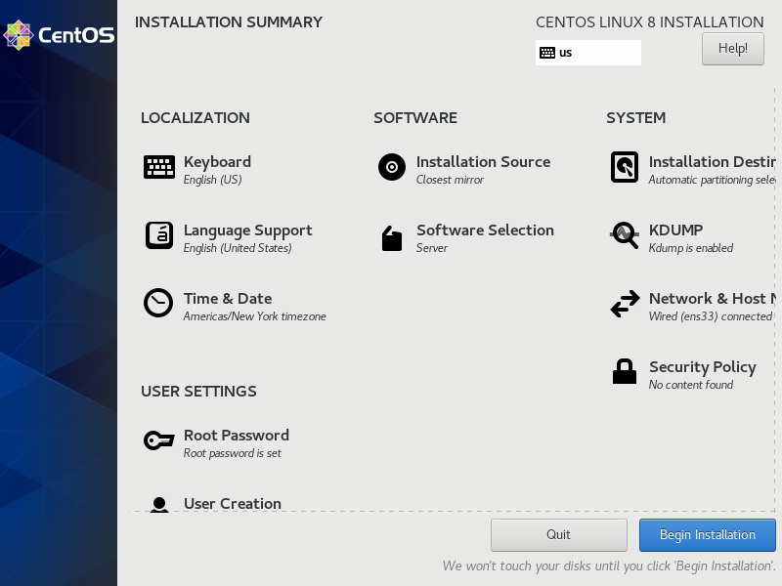Next, you will see this installation summary screen. This summary page is what we will use to configure our CentOS installation.

First, click “Network & Host” and to enable your wired/wireless connection for the installation. Click your network device and then flip the “off” switch to “on”

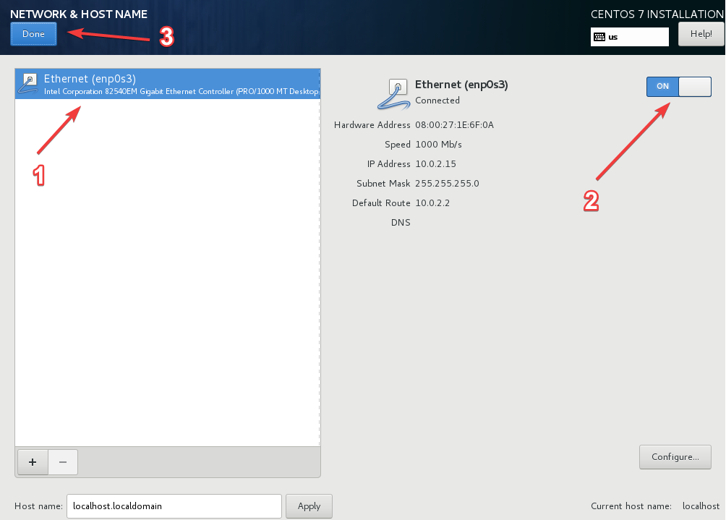

On the installation summary page, click on the icon “Software Selection”. This will bring up a new page with two different categories, base environment and additional software. Under the base environment category, select “Server”. The reason why we are selecting this is because we want the CentOS installation to use only the Command Line Interface instead of the GUI or minimal installation.

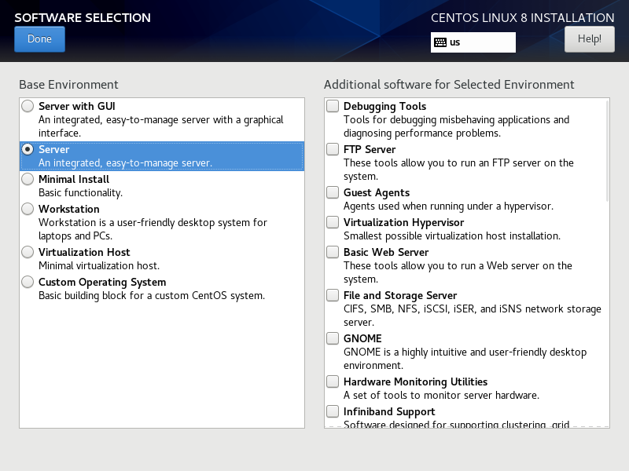

Next, we will browse the category “Additional software for Selected Environment”. This selection allows us to add additional software to our CentOS 8 server. First check off “Debugging Tools”. This will give us additional tools for debugging applications or performance issues. Next, scroll down and check off “Hardware Monitoring Utilities”, this set of tools allows us to monitor the server hardware. Another additional software that we may need is “Legacy UNIX Compatibility”. Check the box for this add-on incase we need more compatibility for legacy UNIX environments. Lastly, check off “Development Tools”. These tools are useful for building packages.

After finishing this configuration, click “Done”.

When returning to the installation summary screen, you should see “Server” under software selection. While on this screen, click “Root Password” and enter a new password for the root user. After creating a strong password, you may also configure a new user under “User Creation”.

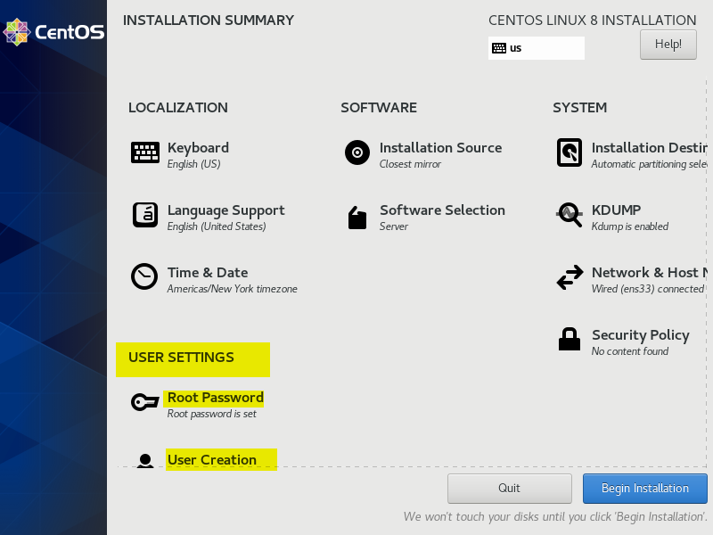

Click “Begin Installation” to finish the CentOS 8 server installation. The installation will then begin finalizing and may take around 10-20 minutes before it completes. When booting into the new operating system, please remove the ISO to prevent booting back into the installation media. The installation is now complete and CentOS 8 is properly up and running using the Command Line Interface. You can now login to the root user account and start using your CentOS server.

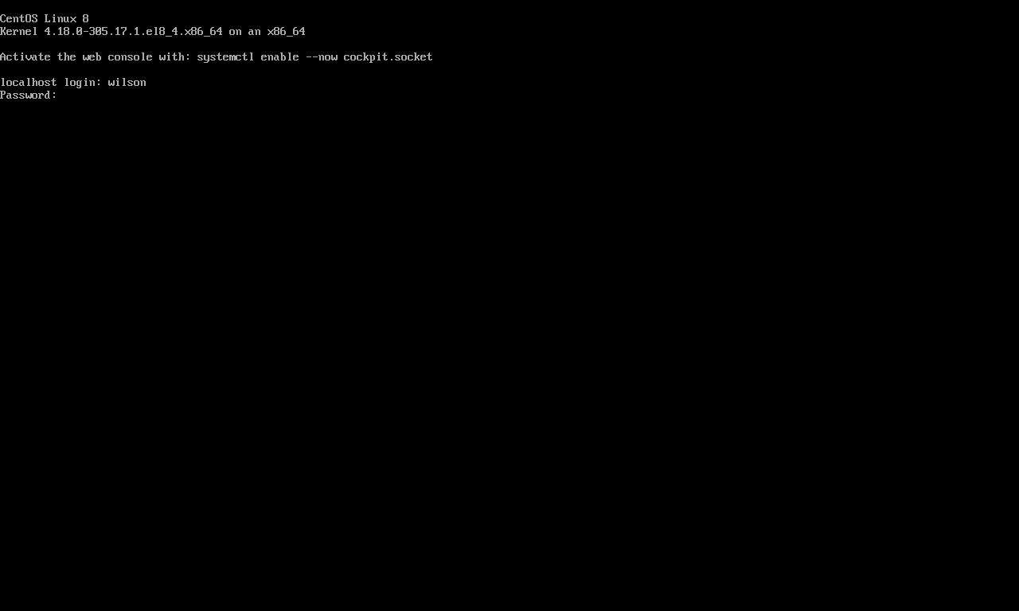

Ubuntu Server

Now that we’re done installing the CentOS server, we can begin set up the Ubuntu server. First, we will download the installation ISO from the official download page. Click “Manual server installation” to begin the download.

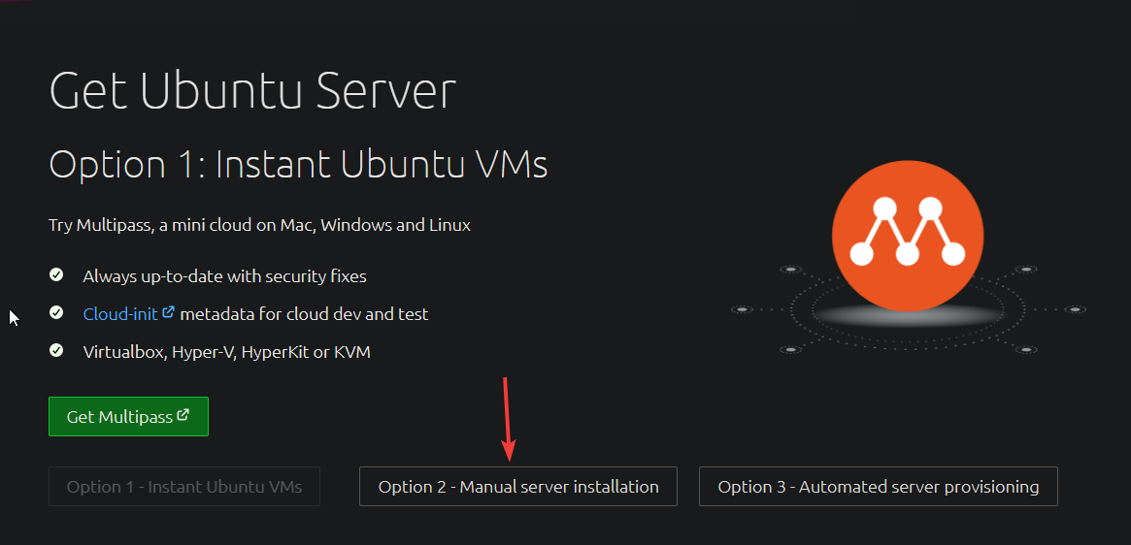

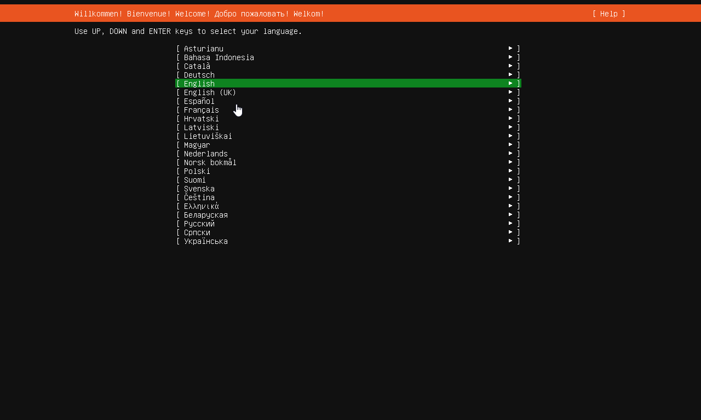After the download completes mount the ISO to begin the installation process. The installation media will load up and you will be met with this page. Use the arrow keys to select your language and keyboard language, then press enter

There will now be a screen called “Network connections”. This will automatically identify your current network adapter to use. If the information the installation provides is incorrect, you may edit the network information manually. If it is correct however, click “Done”.

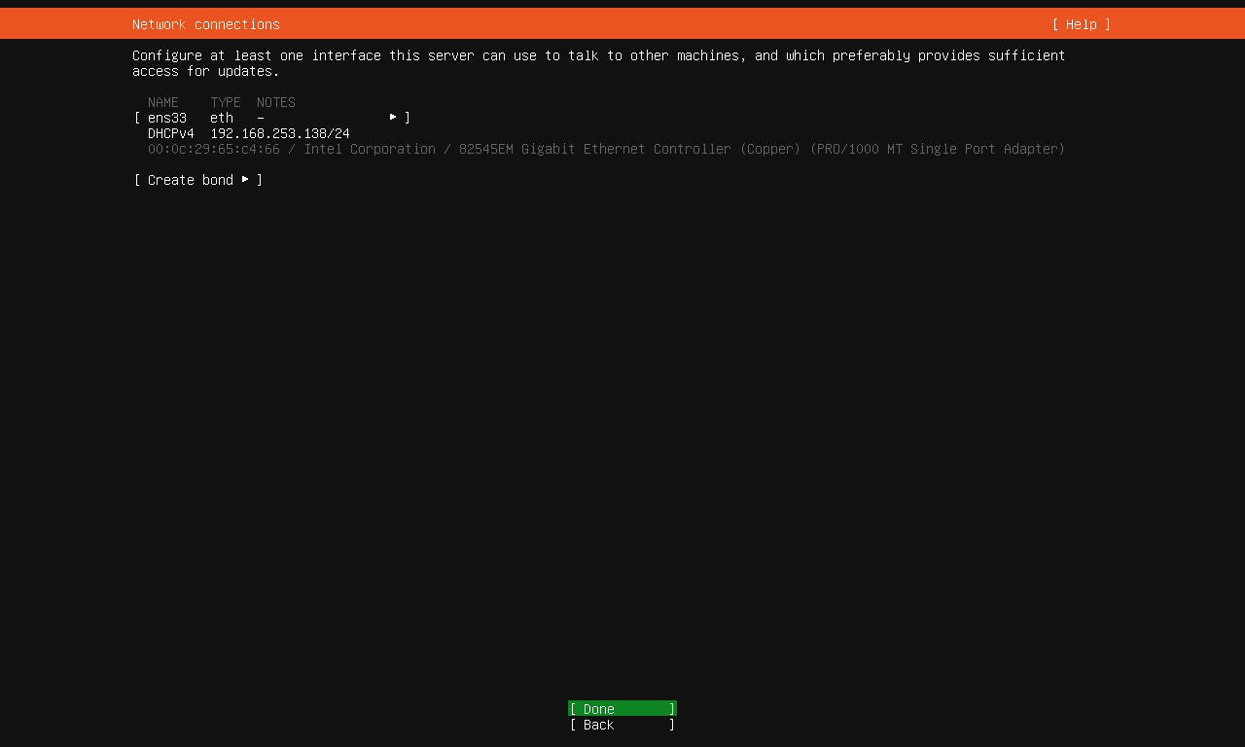

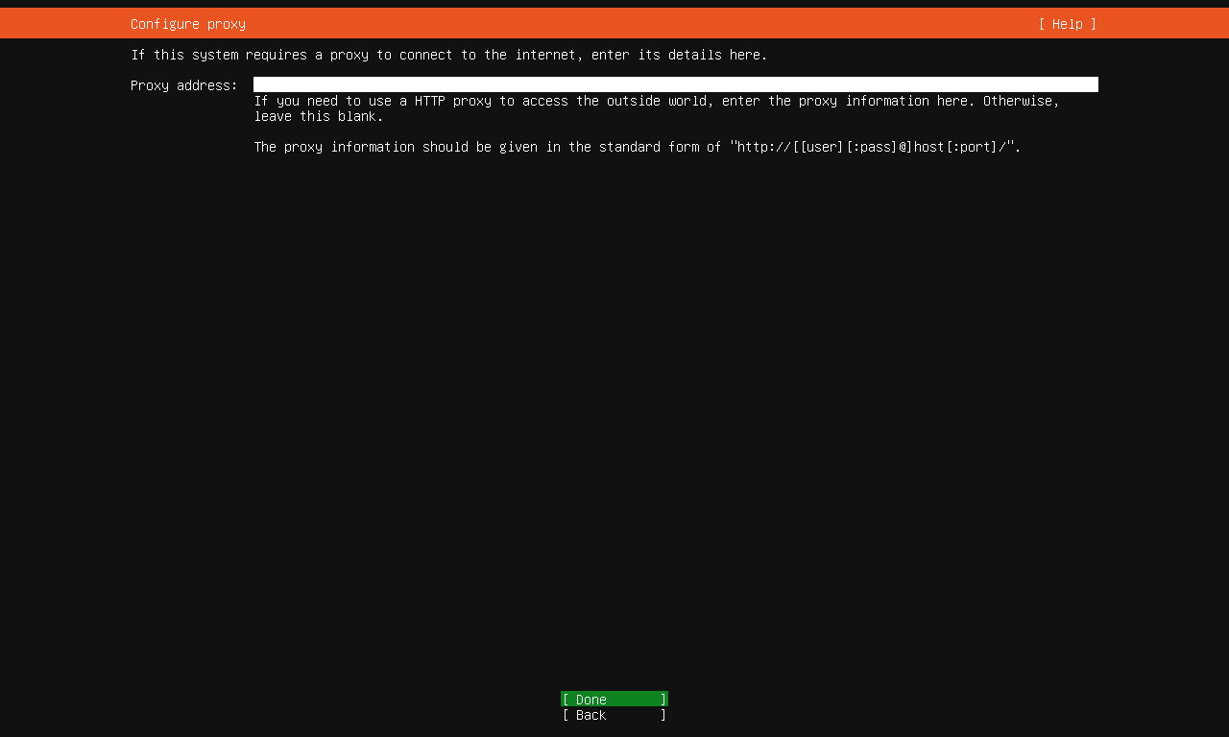The next page is the configuration of a proxy. We will not use a proxy for this server, click “Done”

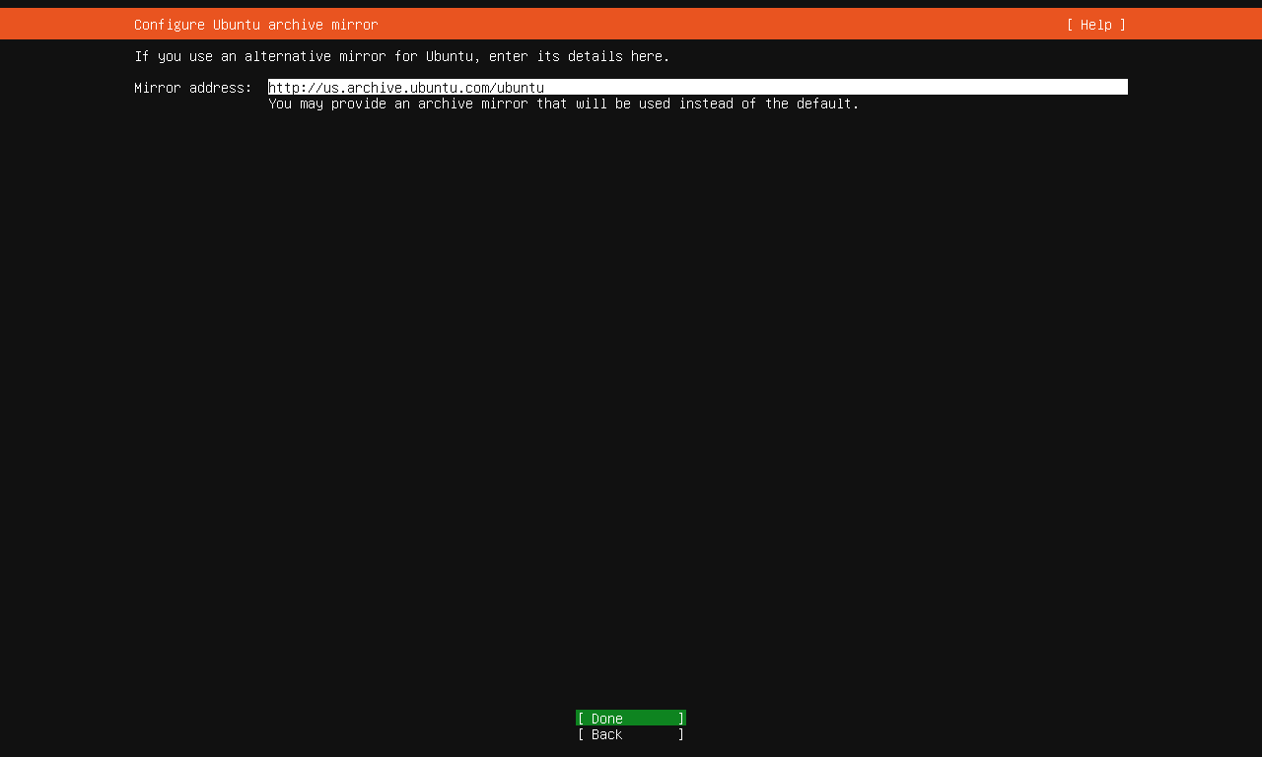On the next page is an option to use an alternate mirror for Ubuntu. Since the current URL is suffient, we will not need to input an archive mirror. Instead, click “Done”.

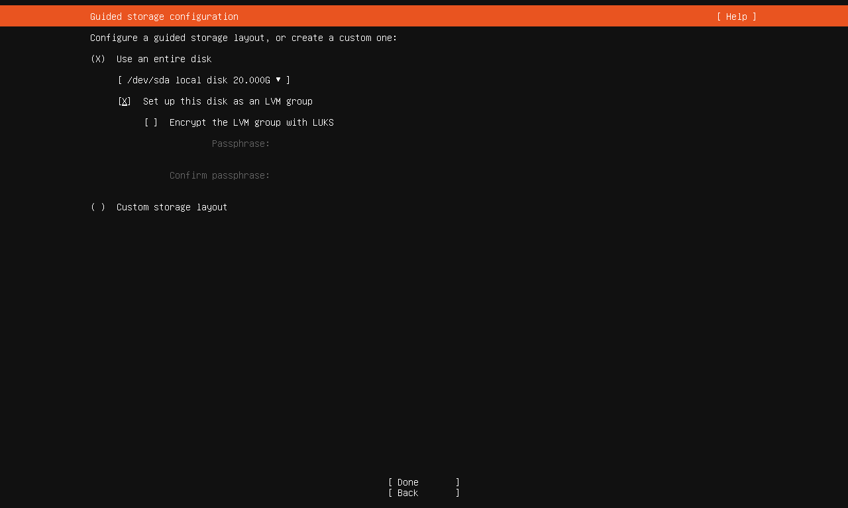After this you will see a page called “Guided storage configuration”. For this computer, I will be using my entire disk space however if you would like to only use a certain partition, select “Custom storage layout”. Click “Done” to proceed.

Next we will be setting up a user to use for our Ubuntu Server. Enter your name, the name of the server (in my case the server name will be ACME-CORP) a username and a strong password. After this, click “Done” to continue.

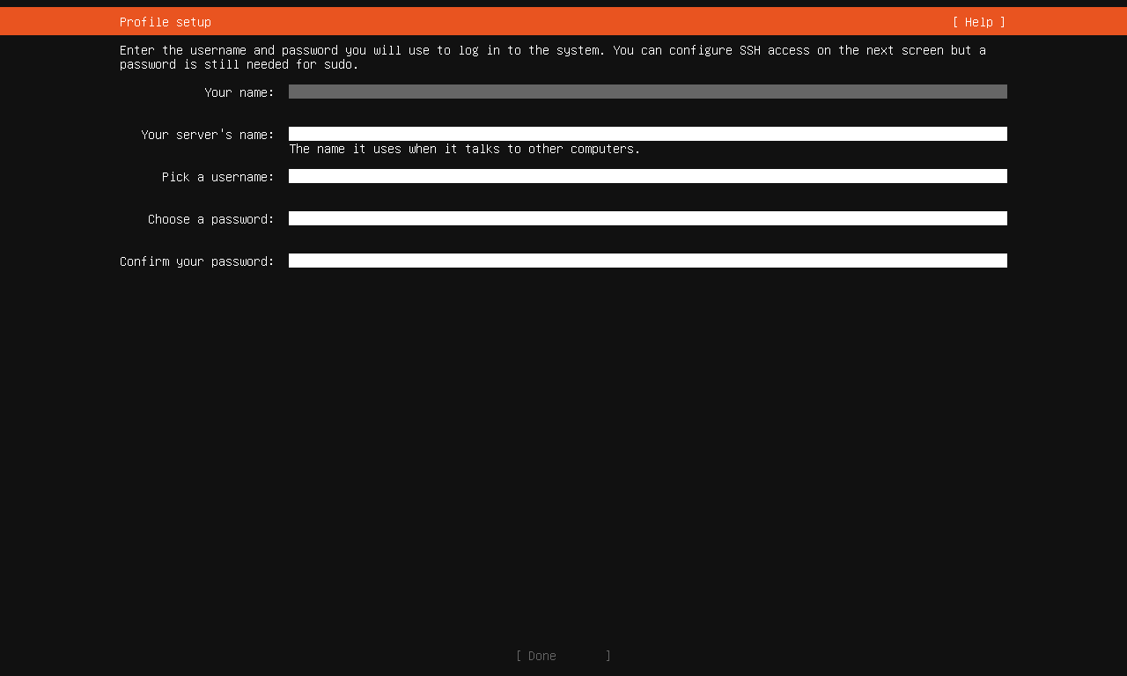

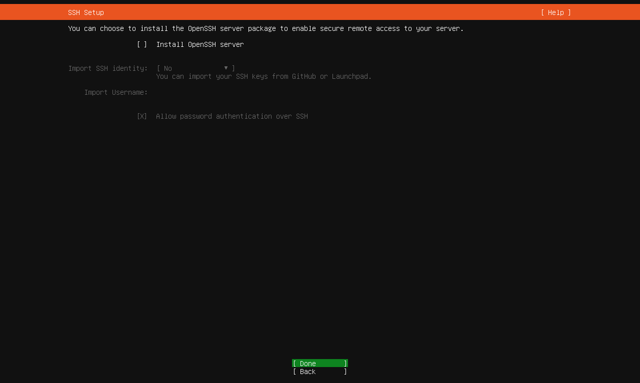For now we will not install the OpenSSH server, click “Done”

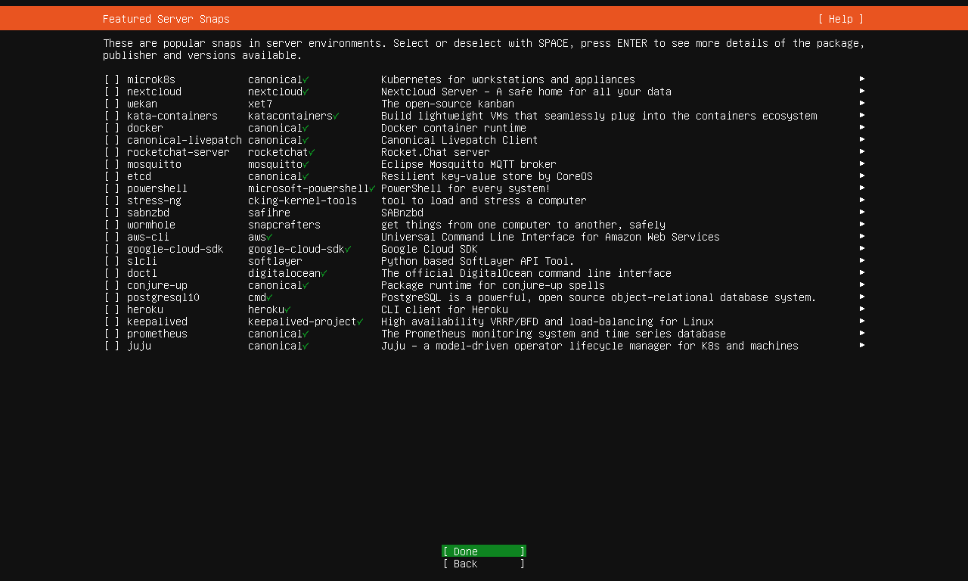

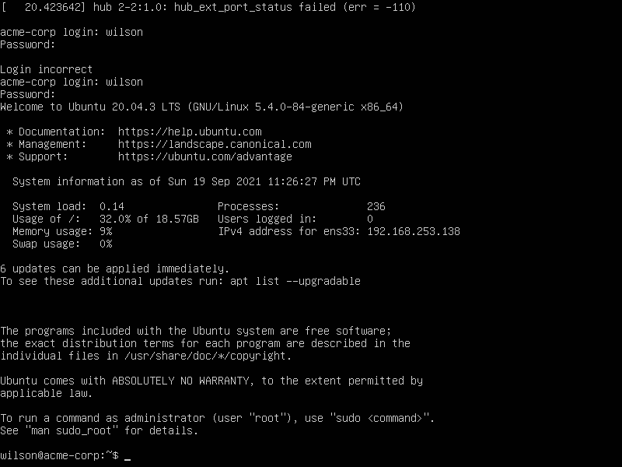For now we will not use any server snaps, click “Done” to continue. You are now done with the installation and can now reboot into the new system. When booting, remove the installation ISO and you can now enter the operating system. You can now login to start using the Ubuntu Server.

Additional Software/Configurations

In my installation of CentOS I have added the additional software development tools, debugging tools, hardware monitoring utilities, and legacy UNIX compatibility. I have also enable the installation to only use command line mode instead of a GUI or minimal installation. For my Ubuntu installation, I mainly used a standard configuration without additional server snaps or the addition of remote SSH.